**Auto/Manual re-transfer of file in case of any issues (Ensuring file integrity)**

Step 1:login to B2B Dashboard console.

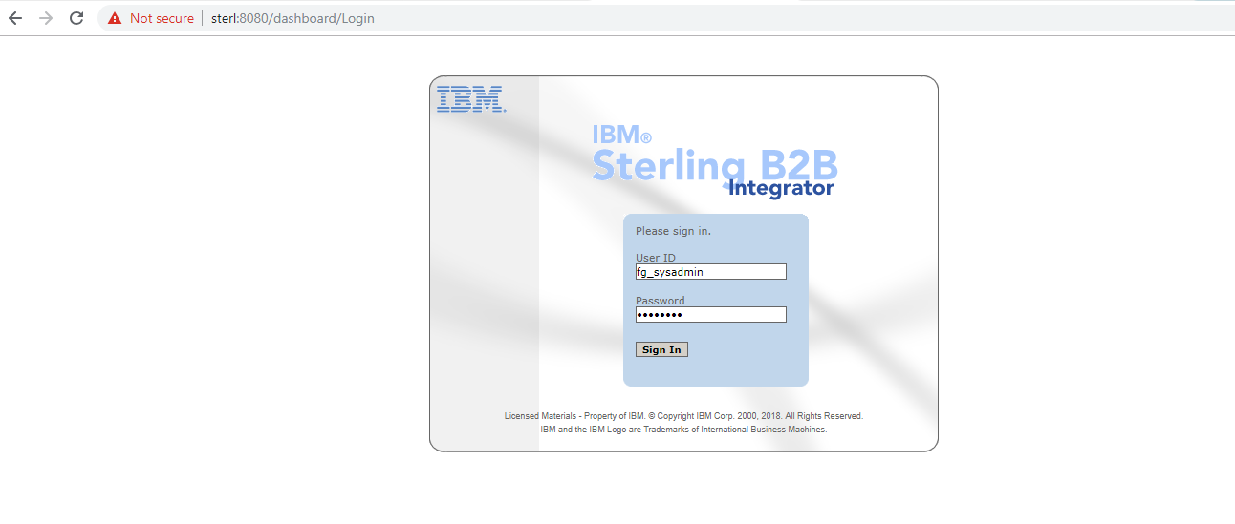

User can able to see dashboard

Step 2: Go to Administration Menu

Click on Business Processes >> Monitor >> Current Processes

User can able to see all current Processes

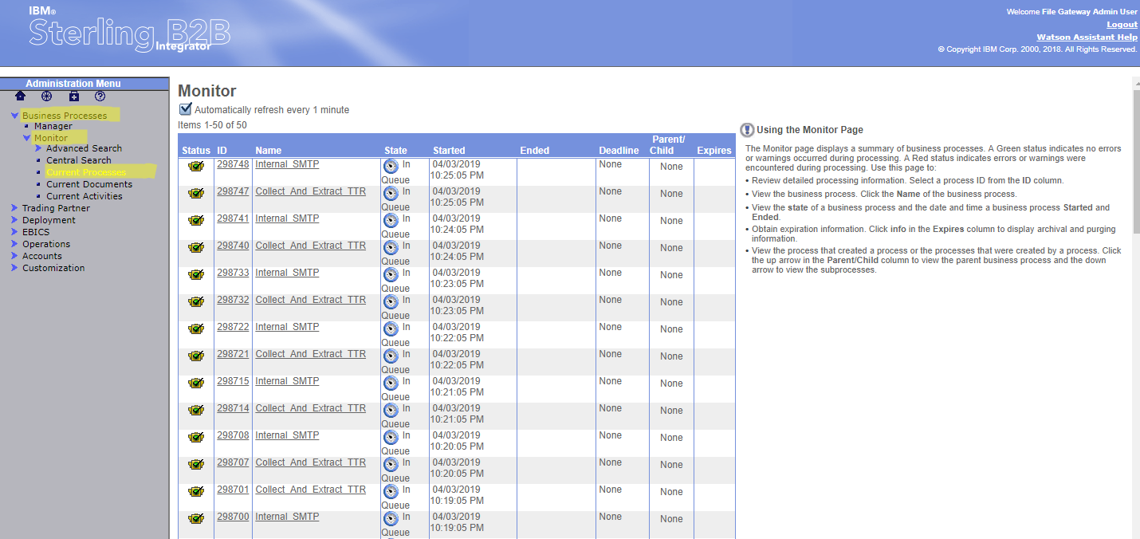

User can perform 3 actions on Current available instances.

Step3: Click on the current instance id in the Monitor.

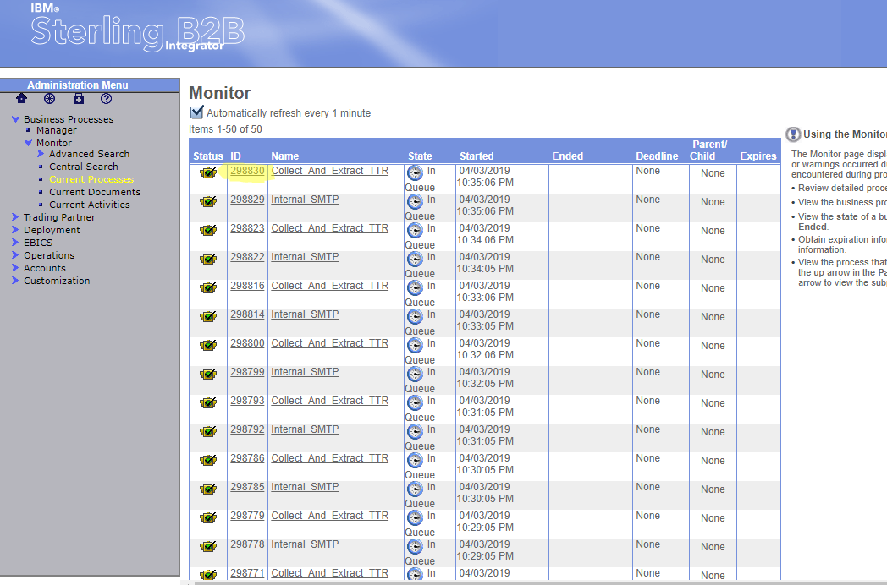

After clicking on Instnace ID user can able to see below Screen

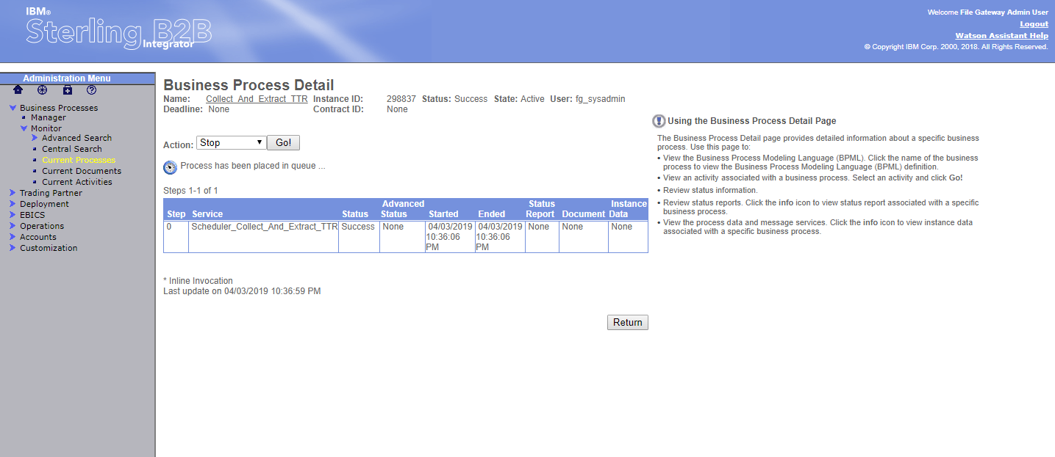

By clicking on Action dropdown user can select Stop, Expedite, XML report

Stop: User can stop the instance by clicking on Go

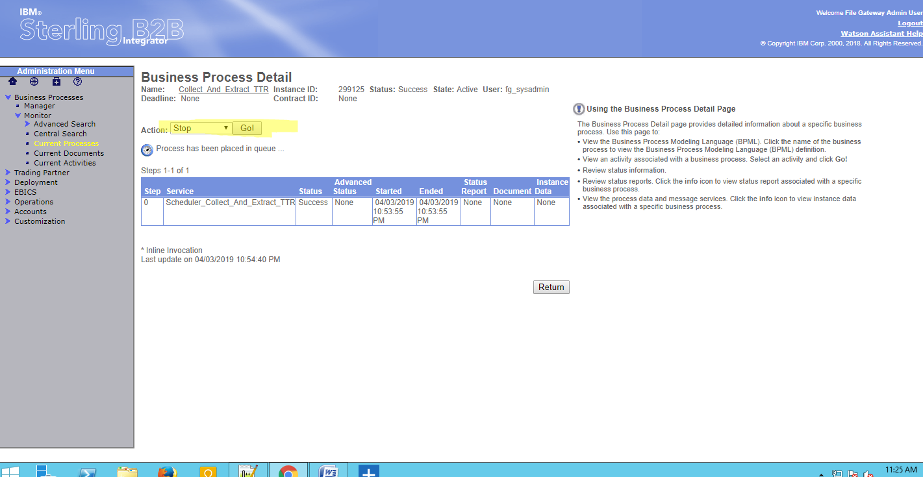

XML report: User can get the Implementation code for Process and its status in the xml

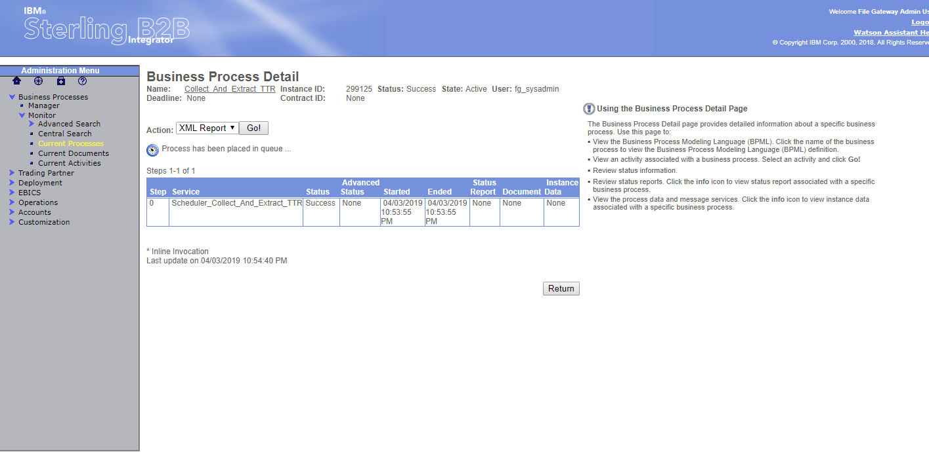

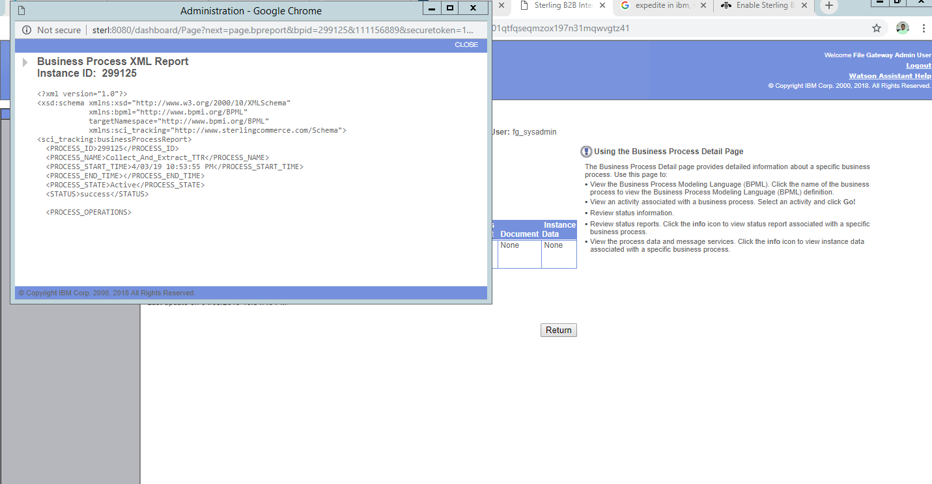

Expedite: User can Terminate by clicking on the Expedite.

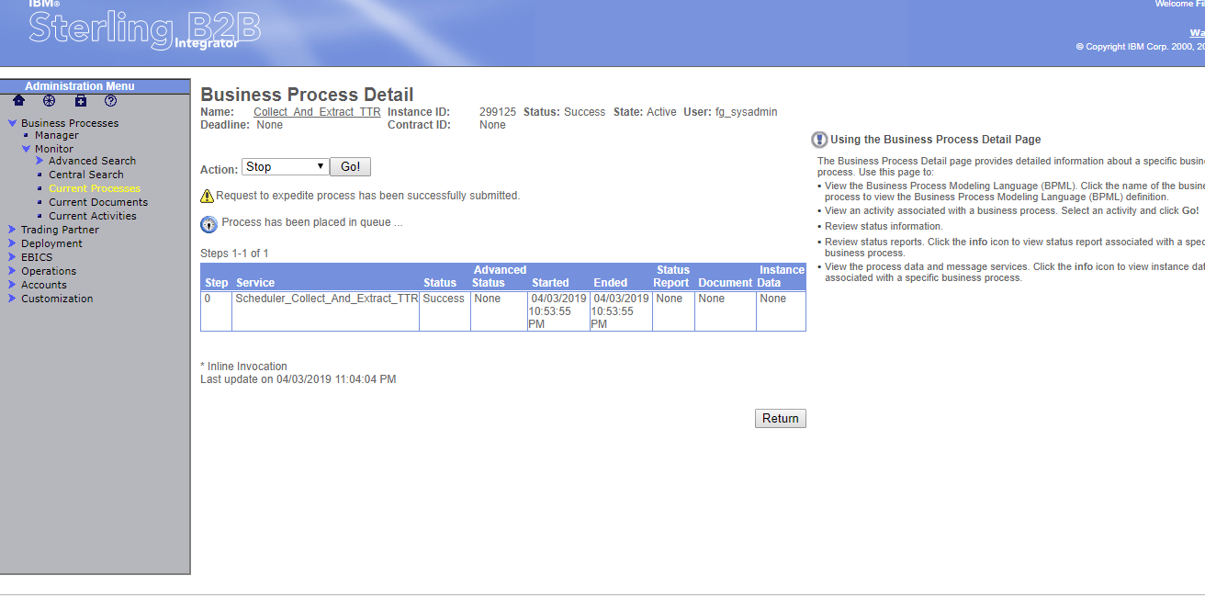

<https://www.ibm.com/support/knowledgecenter/en/SS3JSW_5.2.0/com.ibm.help.stds800_as1.doc/t_STDS_AS1_RunRestartAndStopBusinessProcesses.html>